**LIVE WEATHER APP**

# **AIM**: -

TO CREATE A LIVE WEATHER APP USING PYTHON

# **OBJECTIVES: -**

* Design and implement an intuitive and user-friendly graphical user interface (GUI) for the weather app using a GUI library such as Tkinter.
* Allow users to input the name of a city for which they want to

check the weather.

* Integrate with a weather API (e.g., OpenWeatherMap API) to retrieve live weather data based on the user-entered city.
* Ensure that the app supports the integration of API keys for accessing external weather data.
* Conduct thorough testing to identify and fix bugs, ensuring the app functions correctly under various scenarios.
* Provide an opportunity for developers to learn and enhance their skills in GUI development, API integration, error handling, and more.

**PROGRAM: -**

**OUTPUT: -**

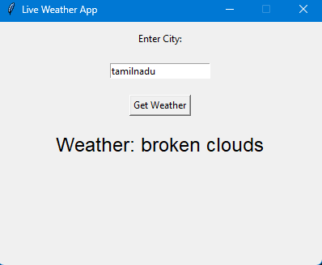

**CONCLUSION: -**

In conclusion, the live weather app project provides a simple and interactive way for users to access real-time weather information for a specified city. The application utilizes the OpenWeatherMap API to fetch live weather data, including a detailed weather description and an icon representing the current weather conditions.